CS-011 Inventory, Storage & Transport
Doc ID | CS-011
Title | Inventory, Storage & Transport
Revision | E
Status | Draft, pending Lead signature (storage-map locations to field-verify)
Effective date | 2026-10-10
Supersedes | The stale Master Tracker Inventory sheet as a live record

Approvals
Role | Name | Date
Author | Simon Starbuck (drafted with Claude, SN6 Resources) | 2026-07-12
Reviewer | simon (reviewer agent) | 2026-10-10
Approver (Composites Lead)

Revision history
Rev | Date | Author | Description of change
A | 2026-07-12 | Claude | Initial outline
B | 2026-07-28 | Claude | Added a reference to the app's Stock tab and noted its location field is freeform today, not a controlled vocabulary, so it doesn't yet enforce the storage map. Language pass.
C | 2026-08-03 | Claude | §7.3 storage map: locations become records with their own labels, so the location field is a controlled value rather than freeform text (CS-001 §7.10).
D | 2026-08-28 | Claude | Engineering pass (CS-000 Rev C conventions). §7 dropped its "(outline)" label and its five run-on items became titled subsections; the storage-map paragraph was split so the rule, the mechanism and the payoff read separately. No rule changed.
E | 2026-10-10 | Claude (doc overhaul, requested by Simon Starbuck) | §5 is now the app's restock table (Material type, unit, supplier, lead time) and says how a lead changes a minimum. §7.1 walks the shelves the way the app does and sends reorders to #purchasing-slackbot, since #purchasing was retired 2026-10-07. §7.3 uses the app's site names and Inventory → Boards. New §7.6 gives resin storage temperatures from the TDSs. §8 adds a no-chemicals-in-a-fridge check; §8 and §9 name the app records. Scope adds foam, core and donated stock. Tacky tape supplier set to Airtech AT-200Y (Simon, 2026-10-10). Crystallized 105 points to CS-008 rather than repeating it. §6 and the three disputed §5 minimums are unchanged, held for Simon. Register R-011-03, R-011-05..15, R-011-30 (§7.2 retitled), R-011-31 (Flammables cabinet row), R-000-09, R-008-10, R-014-05. The held spots (§5 minimums, §6) are marked.

1. Purpose
Our SN5 inventory sheet was written at season start and then never touched. MEKP sat flagged "REORDER" for months with no owner and no trigger, and when the October Easy Composites order got stuck in customs we had no buffer and lost weeks of layups (PP-02). Storage was purely reactive: parts got evicted from the etch locker, molds blocked everyone's boxes at RFS (PP-10). This doc sets minimum stocks, gives them an owner, and maps where things live.

2. Scope
Consumables, resins and chemicals, cloth, tooling board, foam and core stock, molds, finished parts, and donated or sponsor material: where they live, when they get reordered, how they move. Receiving a delivery into the app and the lot records it makes are CS-014.

3. References
Ref | Document | Where
R1 | PP-02, PP-10 RCAs | FEB-COMP-PP-001
R2 | CS-012 (ordering process + lead times) | CS-012
R3 | CS-001 (labels carry home locations) | CS-001
R4 | SDS chemical storage sections | 03 Datasheets/
R5 | The app's Inventory tab (Storage map, Materials list, Boards) | 06 Composites App/app/README.md
R6 | CS-014 (receiving, lots, opening and emptying containers) | CS-014
R7 | Resin TDS storage sections: IN2/AT30, XCR, West System 105 with 205/206/209 | 03 Datasheets/EC-TDS-IN2-Infusion-Resin.pdf, 03 Datasheets/EC-TDS-XCR-Epoxy-Coating-Resin.pdf, 03 Datasheets/west-system_slow-epoxy-hardener_206_tds.pdf, 03 Datasheets/105_205-207-Combined.pdf, 03 Datasheets/105-209-Epoxy-Resin-1.pdf

4. Definitions
- Min-stock: the level that triggers a reorder, sized so the order lands before stock-out at the supplier's lead time.
- Stock walk: the monthly check of every shelf against its record (§7.1). The app records it per shelf as Contents last confirmed and Confirmed by.
- Home location: the storage record (BIN-SN6-###) an object belongs on. Molds and material lots carry it in their Home location field.
- Lot: one recorded container or roll (FAB-SN6-###, RSN-SN6-###, CON-SN6-###); a consumable lot is one record with a count. CS-014 owns lots.
- Material type: the app's name for a kind of material across every container of it, for example IN2, AT30 or WEST-105. Restock rules and a shelf page's grouping both key on it.
- Restock rule: one row of the §5 table as the app holds it: Material type, minimum, unit, supplier and lead time.
- How full: a lot's level, Full, Half, Low or Empty. An Empty container counts as zero toward the minimum; an opened one counts as one container (app/inventory.js, restockOnHand).

5. Minimum stock: what we never run out of
These are starting values, tuned with usage data. Sizing rule (§4): min stock = (burn rate × supplier lead time) + one job's worth. Worked examples for the three items that actually stop a layup; the rest of the table starts as one-job buffers, tuned with WO usage data:
- IN2 + AT30: about 1.95 kg mixed per large infusion (team estimate; no logged source); at the 2-infusions/week peak that is ~4 kg/week. Easy Composites lead ≥6 weeks (CS-012) → running dry mid-season costs ~6 weeks of infusions. One unopened kit (~4 kg, team estimate) ≈ 1 peak week: it is the alarm, not the buffer. When the walk finds only the unopened kit, the order is already late, so trigger at opened kit + 1 unopened, and place the big seasonal orders per CS-012 §7.4 so the walk never trips this.
- XCR: ~1 kit seals 2–3 mold sections (tune from WO records); molds queue 2/week in peak → 1 kit ≈ 1 week. Same logic: 1 unopened kit minimum, ordered with every EC basket.
- Tacky tape: every bagged job uses 1–2 rolls of perimeter; 2 jobs/week → ~3 rolls/week; domestic lead ~1 week → 6 rolls ≈ 2 weeks of peak burn.
Material (Material type) | Minimum | Unit | Supplier | Lead time | Why it blocks
IN2 infusion resin (IN2) | 2 on hand, one may be open | kit | Easy Composites | 42 days | Every infusion; 6-week EC lead
AT30 slow hardener (AT30) | 2 on hand, one may be open | kit | Easy Composites | 42 days | Pairs with IN2
West 105 + 206 (WEST-105, WEST-206) | ½ tank + 1 can [held for Simon: R-011-04; the app holds 1 tank] | tank, can | West System | 14 days | Every wet layup
XCR (XCR) | 1 [held for Simon: R-011-04; the app holds 2] | kit | Easy Composites | 42 days | Every mold
VB160 bag film (VB160) | 1 | roll | Easy Composites | 42 days | Everything bagged
Peel ply (PEEL-PLY) | 1 | roll | Easy Composites | 42 days | Everything bagged
Flow mesh (FLOW-MESH) | 1 | roll | Easy Composites | 42 days | Everything infused
Tacky tape (TACKY-TAPE) | 6 | roll | Airtech (AT-200Y, 03 Datasheets/AIRTECH-TDS-AT-200Y-Sealant-Tape.pdf) | 7 days (team planning value) | Everything bagged; team burns it fast
Nitrile gloves (GLOVES-NITRILE) | 2 | box per size | McMaster | 7 days | Everything
Mixing cups (MIXING-CUPS) | 50 | cup | McMaster | 7 days | Everything
Mixing sticks (MIXING-STICKS) | 50 | stick | McMaster | 7 days | Everything
Respirator cartridges, A + P100 (CARTRIDGE-A-P100) | 2 | set | McMaster | 7 days | Safety-blocking
195 twill cloth (195-TWILL) | 10 [held for Simon: R-011-04; the app holds 1 roll] | yd | Sigmatex (sponsor) | 30 days | Most stacks

Lead times are the team's planning values from the app's restock table (app/inventory.js, RESTOCK_SEED); Easy Composites' 42 days is the ≥6 weeks of §7.2 (PP-02).
The app holds this table as its restock rules, and those are the live values: the Running out card on Inventory → Storage map lists every Material type at or below its minimum. Until R-011-04 is decided, three rows differ from the app: it holds XCR at 2 kits, West 105 at 1 tank and 195 twill at 1 roll, and the Running out card uses the app's values. A lead tunes a minimum by editing config/restock in the Firebase console; there is no editor in the app. A change there is a change to this table, and the lead who makes it shall open a revision of this standard within two weeks (CS-000 §2, §7.2).
A Material type appears on Running out only once at least one lot carries it. The Receiving desk fills it from a typed name (CS-014 §7.3 step 6); rows filled by Arrived ▸ or Take all do not get one. For a lot that still has none, press Link materials on the Materials list (CS-014 §7.7 step 3) or set it with Edit on the lot.

6. Safety
Chemical storage per each SDS (R4): resins/hardeners in the chemical boxes/barrel, never in food fridges (2026-02-17 incident); flammables (Airtac, acetone, clear coat) in the flammables cabinet; segregate hardeners from resins on different shelves.
[held for Simon: co-storage and the flammables list, REGISTER R-011-01, R-011-02]

7. Procedure

7.1 Monthly stock walk
The walk takes about 15 minutes (team estimate). An IA or first-year is the right owner; it is a good first responsibility.
- The lead names the stock-walk owner at the start of the season.
- Once a month, open Inventory → Storage map and walk each shelf: open its card, check the list against what is on the shelf, and press Confirm contents (Confirm on the map card does the same).
- Fix what is wrong as you go: Move for something on the wrong shelf, How full on a container, and the shelf's Add here card for anything missing.
- Open the Running out card on the storage map. If any row lacks "on order", press Add N to a purchase, pick A new purchase or an open purchase under Add to, and press Add to purchase.
- Post the purchase request in #purchasing-slackbot the same day (CS-012 §7.1).
Between walks, open one container of a material at a time and mark an emptied container Empty rather than deleting it: the cure buy-off pre-fills the most recently opened lot, and the reorder count needs to see the empty one (CS-014 §7.8).

7.2 Order timing: when to order resin and cloth
One big fall order plus one spring top-up beats four rushed baskets.
- Place Easy Composites orders at least 6 weeks before the material is needed: UK shipping plus customs (PP-02).
- Order on the calendar in CS-012 §7.4: one big fall order and one spring top-up.

7.3 Where things are stored (storage map)
Where to store or keep molds, parts, cloth, chemicals and consumables:
Object | Site (as the app names it) | Rule
Molds | RFS container | Never in front of the knaack or screw boxes (PP-10)
Foam and tooling-board stock | RFS container | Board stock goes on Inventory → Boards (step 1)
Finished parts | Jacobs basement | Never the etch locker (2026-04-20 agreement); keycard access
Cloth | Dry sealed bin | None beyond the site
Resins and hardeners | No app Site names them yet; per §6 | Never in a food fridge (§6)
Flammables (what goes in it: §6) | Flammables cabinet | Rated cabinet only
Consumables | General Box | At RFS
Anything else | Other | Name the location after the place

These sites still need a field check against the real shelves.
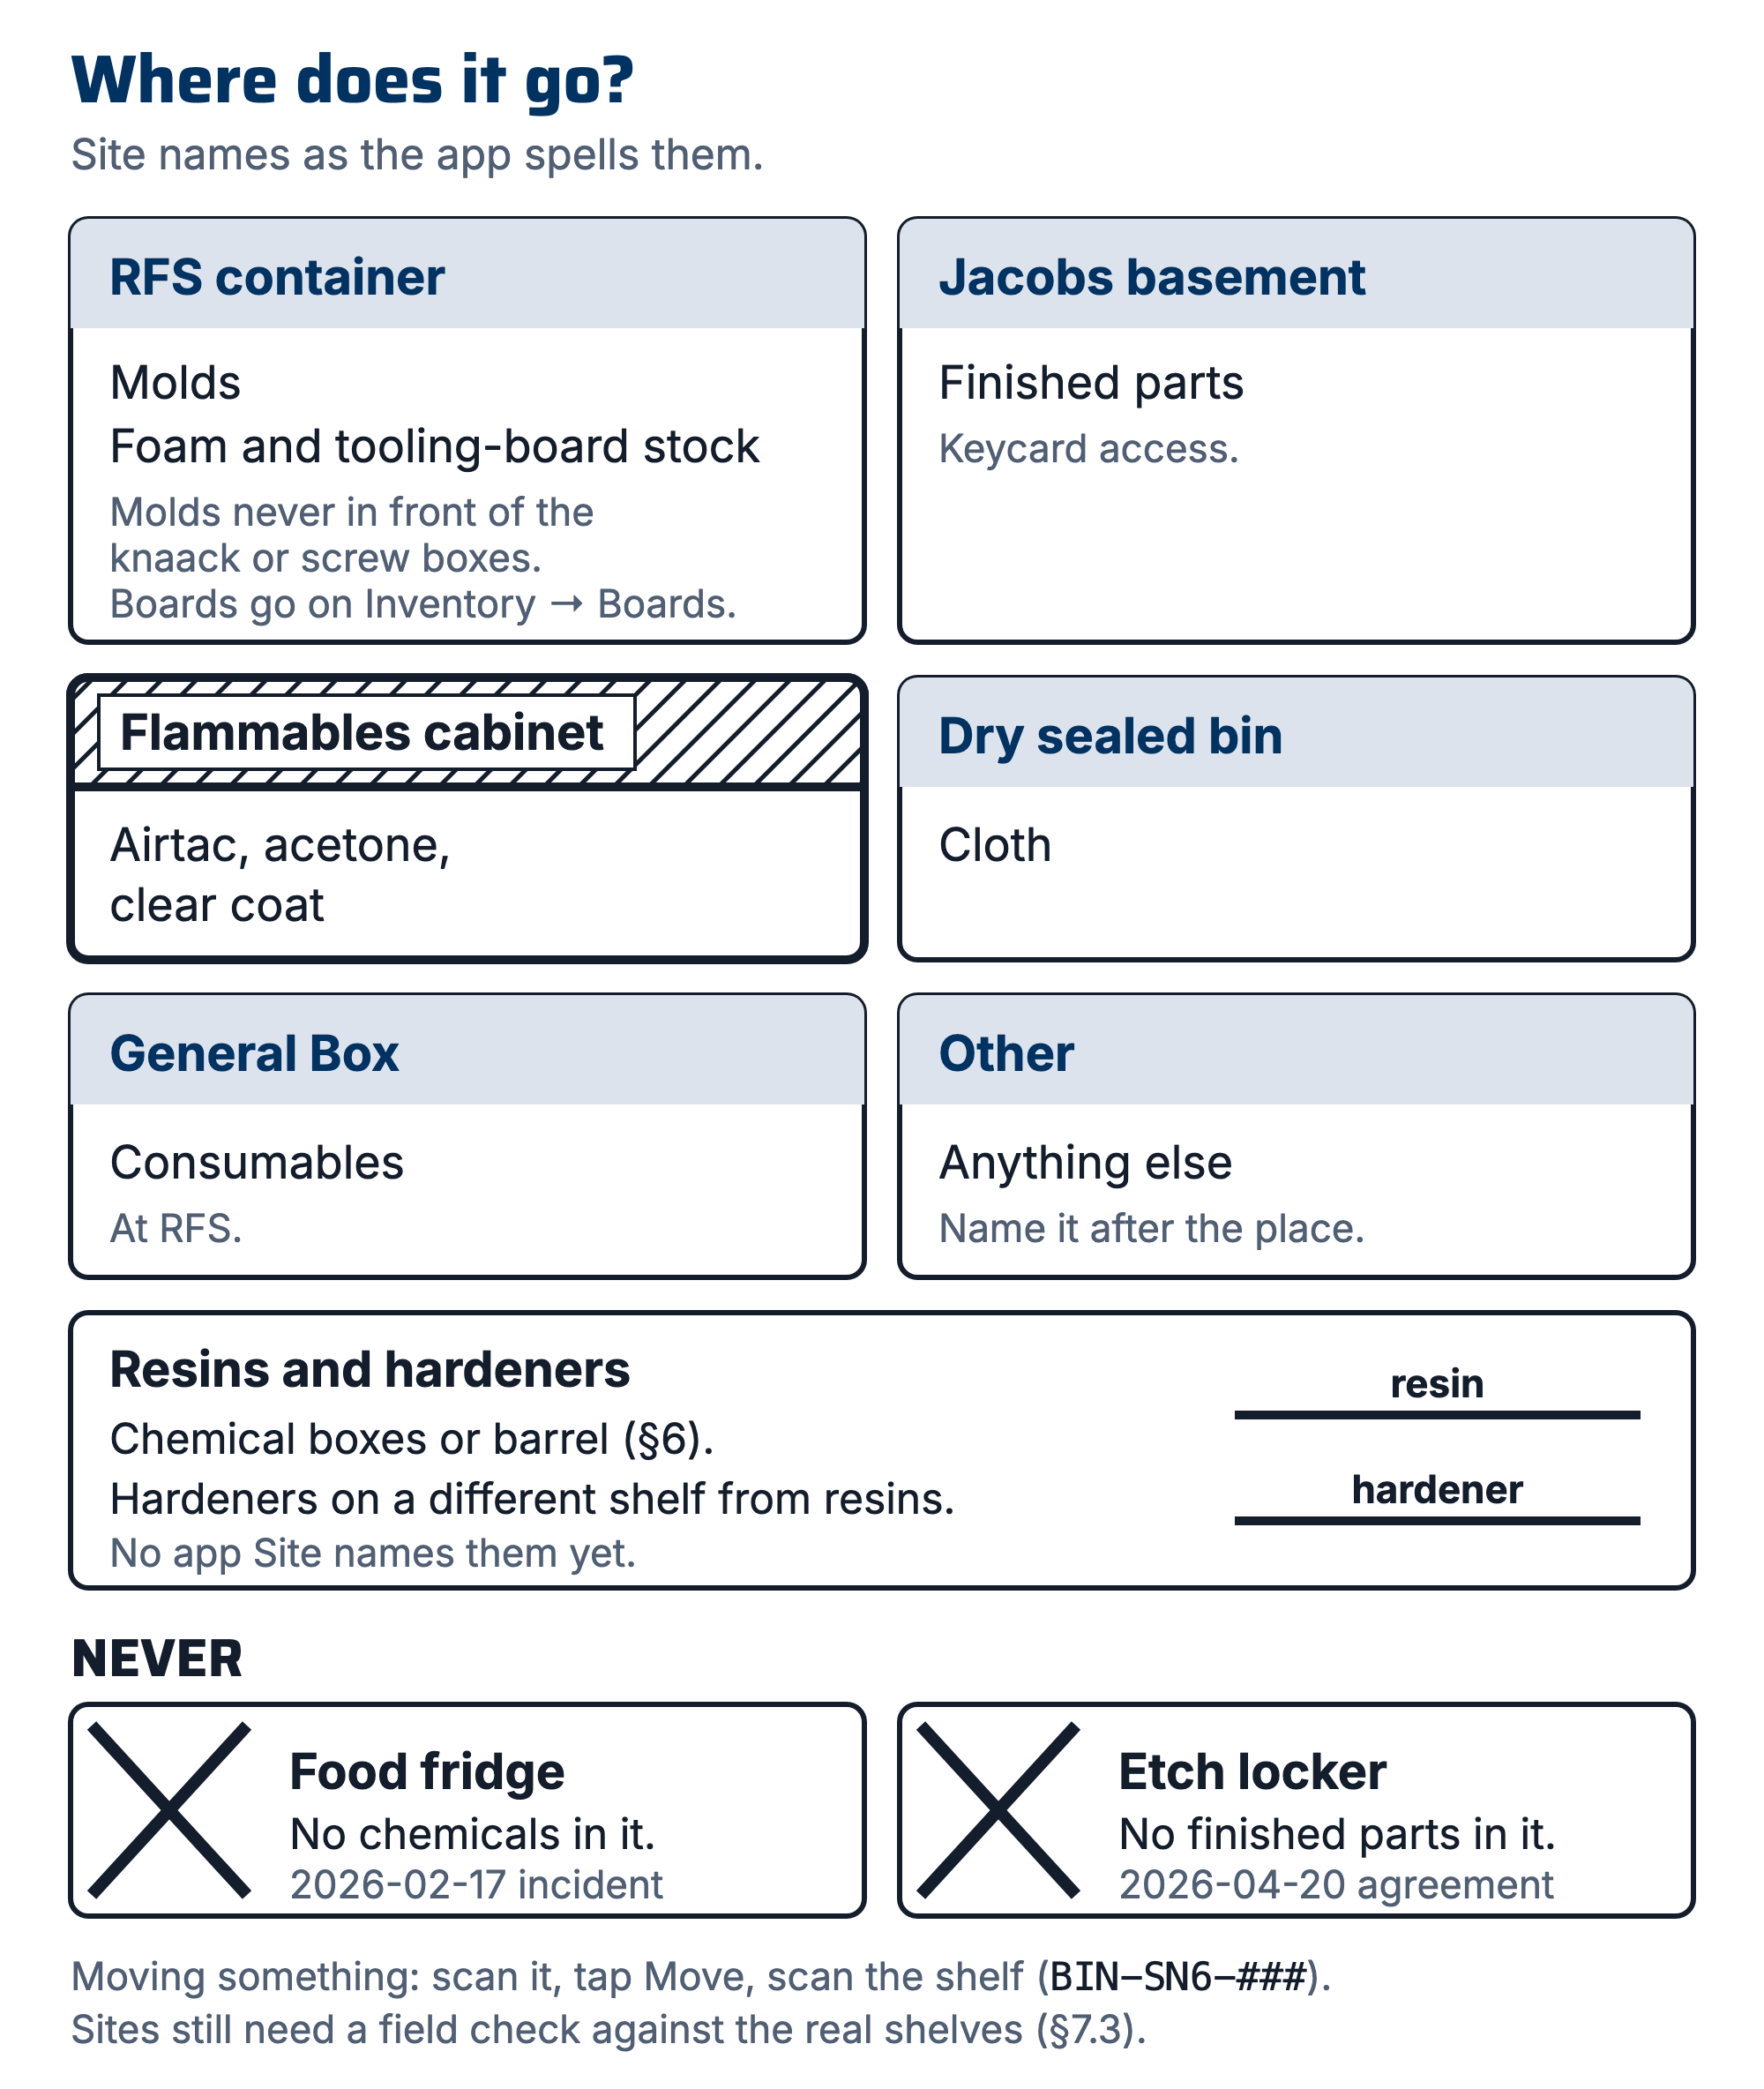
Figure 1. Where things are stored, by site

- Log tooling boards and offcuts under Inventory → Boards (R5); that is where real board inventory lives day to day.
- Every shelf, bin and rack gets a storage record (+ Location on the storage map, with its Site set from the table above) and a printed label on its front edge (CS-001 §7.10), and every mold, part and material lot points at one.
- To record a move, scan the object, tap Move, scan the shelf. To put several things on one shelf, open the shelf and use Move here (scan).
Since 2026-08-03 this is enforceable: "where is the seat mold" is a lookup rather than a Slack ask, and the monthly walk checks reality against a controlled value instead of whatever string somebody typed.
A shelf's page folds identical containers into one row by Material type, showing the count (×N), their states, the first expiry and the price. Open the row to see each container: it lists the FEB ID and the EH&S edge code, the last 12 characters printed down the right edge of the UC EH&S tag, so the screen matches the jug in your hand. Print the shelf's page for the walk sheet; every row prints open.

7.4 Transport
- Molds over ~1 m²: two people, and a vehicle that actually fits them. Plan it, don't discover it.
- Parts travel padded and labeled.
The SN5 budget shows a U-Haul was needed for mold moves.

7.5 Season handoff
- At season end, the stock-walk owner and the lead produce the "what we actually have" list for the incoming lead (the 6/15 handoff gap): on Inventory, press Export, then Copy for Sheets on Everything on every shelf.
- Paste it into a new sheet in the season's Drive folder.

7.6 Storage temperature and shelf life (resins, hardeners and XCR)
Keep every resin and hardener container closed. The figures below are datasheet figures (R7), not team holds. Where each container lives is §6 and §7.3.
Material | Store at | Shelf life | Source
IN2 resin and AT30 hardener | 10–25 °C (50–77 °F), tightly sealed | 12 months when stored correctly | 03 Datasheets/EC-TDS-IN2-Infusion-Resin.pdf
XCR resin and hardener | 20–25 °C (68–77 °F), tightly sealed | 12 months when stored correctly | 03 Datasheets/EC-TDS-XCR-Epoxy-Coating-Resin.pdf
West System 105 with 205, 206 or 209 | Room temperature, containers closed | Usable for many years with proper storage | 03 Datasheets/west-system_slow-epoxy-hardener_206_tds.pdf, 03 Datasheets/105_205-207-Combined.pdf, 03 Datasheets/105-209-Epoxy-Resin-1.pdf

- Do not let West 105 freeze and thaw repeatedly: it crystallizes (03 Datasheets/west-system_slow-epoxy-hardener_206_tds.pdf). Crystallized 105 is warmed to 125 °F and stirred before use; CS-008 §7 step 8 owns that step.
- After long storage, check the West pumps' metering and mix a small test batch to confirm it cures (same TDS).

8. Quality checks / acceptance criteria
Check | Target | Method | Record where
Stock walk done | Monthly during build season | Confirm contents on every active shelf; the storage map's "need a walk" chip reads 0 (it counts shelves not confirmed in 30 days, app/inventory.js) | Each shelf's Contents last confirmed and Confirmed by
No layup blocked by stock-out | 0 per season | WO delay notes | WO timeline
Molds in home locations | 100% at walk | Walk | Each mold's Home location; Export → Locations
No chemical lot on a fridge-type location | 0 at walk | Open every location whose Type is fridge and check it holds no resin, hardener or other chemical lot; the app does not warn | Walk

9. Records
Each shelf's Contents last confirmed and Confirmed by fields; each mold's Home location; Export → Locations (Copy for Sheets or Download .csv) as the walk summary; Restock purchases in the Budget tab and their #purchasing-slackbot requests.

